Ishpeming Main Street Program
Volunteer Handbook
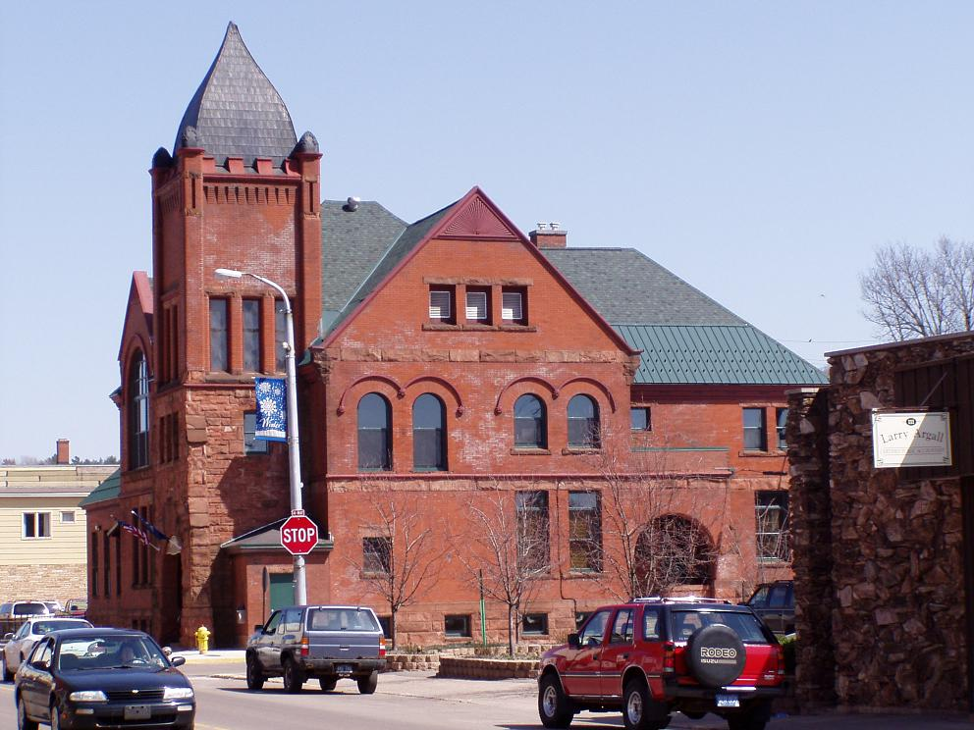
Table of Contents

- Overview of organization
  - Mission Statement 3
  - History of Program 3
  - Role of Each Committee
    - Economic Restructuring Committee 4
    - Design Committee 4
    - Promotions Committee 5
    - Organization Committee 5
  - Characteristics of Strong Coordinating Programs 6
  - Role of Program Director
    - Interaction With All Committees 7
    - Responsibilities By Committee 8

- Information for volunteers
  - What it Means to Be a Volunteer 9
  - How to Get Things Done 10
  - Volunteer Rights and Responsibilities 11
  - Committee Member Responsibilities 12
  - Liability Clause 13
  - Privacy Policy 13
  - Volunteer Interests Form 14
  - Volunteer Application Form 15
  - Volunteer Tracking Form 16
  - Internship Application Form 17

Document prepared by: Don Bickley and Amber Gauthier
Ishpeming Main Street Program
Mission Statement
The Ishpeming Main Street Program’s mission is to empower people, organizations, and communities to achieve ongoing downtown and neighborhood district revitalization based upon the principles of self-determination, resource conservation, and incremental transformation represented through the comprehensive Main Street Four-Point Approach.

History of the Program
The Ishpeming Main Street Program is an economic development organization specifically targeted to provide technical assistance to the City of Ishpeming.

The Main Street Four Point Approach is a comprehensive strategy that is tailored to meet local needs and opportunities. It encompasses work in four distinct areas — Design, Economic Restructuring, Promotion, and Organization — that are combined to address all of the commercial district's needs.

The Main Street Four Point approach is incremental; it is not designed to produce immediate change. Because they often fail to address the underlying causes of commercial district decline, expensive improvements, such as pedestrian malls or sports arenas, do not always generate the desired economic results. In order to succeed, a long-term revitalization effort requires careful attention to every aspect of downtown — a process that takes time and requires leadership and local capacity building.
Goals:
- To improve the physical appearance and restore the historic architecture that is our community.
- To strengthen existing business by providing resources to enable businesses to be successful and create a business resource center.
- To attract businesses that will bring new life and interest into the community.
- To act as a clearinghouse for community activities and special events and to be inclusive.
- To capitalize on Ishpeming’s strengths: its school system, iron mining heritage, natural beauty, and skiing heritage.

The Four Points

The Main Street Program consists of four committees that operate beneath the Program Director. They are tasked with providing specific services that revitalize the downtown area. Committee members may have associations with other economic and governmental organizations; such associations are encouraged as they help broaden the networking capability of the Main Street Program.
Economic Restructuring Committee
The purpose of the Economic Reconstructing committee is to evaluate the economy of downtown Ishpeming. It is their role to find out why businesses are not putting money into their buildings and to see what the committee can to do help business owners invest in those structures, either through grants, incentives, or other means. This committee also researches the market conditions to find out what businesses are missing from the downtown area. Through this research, they expand and diversify the existing economic assets of downtown as well as strengthening what already exists.

The Economic Restructuring Committee also recruits new businesses compatible with existing businesses to build a commercial district that responds to consumer’s needs. Converting unused or empty commercial space into productive new businesses helps boost the profitability of the district. They also work to create ties with other local and national governmental and economic organizations.

Potential volunteers should have some kind banking, finance, or other economic experience in order to be able to properly input their help with the committee. However, all volunteers are welcomed and needed. Volunteers may do everything from business writing to conducting marketing and research surveys.
Design Committee
The Design Committee’s purpose is to enhance the overall beauty of downtown Ishpeming. They are responsible for incorporating downtown beautification, ranging from professional talents such as architectural visualization to nonprofessional—street cleaning and basic landscaping. One goal is to create a standard for the aesthetics of downtown by capitalizing on the downtown’s best assets, including historic buildings and pedestrian-oriented streets. By providing input ranging from sign design to landscaping and attractive window displays, their work helps instill residents and tourists with a positive image of downtown.

The Design Committee is involved with projects that need both technical and general help. Some of these professional skills include: design, landscaping, architecture, or construction experience. Non-professional skills include gardening, trash pickup, communicating the vision of the Deign Committee to businesses and general public, and everything else in between.

Promotions Committee
The Promotions Committee creates a positive image of downtown by creating an atmosphere that encourages people to live, work, shop, play and invest in the Main Street district. The Promotions Committee markets downtown Ishpeming’s unique characteristics to residents, visitors and business owners. It creates a positive image through advertising, special events, and marketing campaigns carried out by local volunteers. These activities improve consumer and investor confidence in the district and encourage commercial activity and investment in the area. This committee plans and executes events that might not benefit a specific business but the overall Main Street as a whole. These events may include concerts and other social gatherings downtown, uniting businesses for promotional sales, and proactively advertising the downtown to a public that may be unappreciative of what their city offers.

The Promotions Committee needs dynamic and active volunteers. Volunteers will do everything from staffing promotional events, posting flyers for events, designing signs, and spreading the news about the event to the public. Because the needs of the Promotions Committee are always changing, they generally have the greatest need for volunteers. Consequently, volunteer tasks will have the greatest diversification compared to the other committees. A good volunteer will be adaptable and willing to try something new in order to benefit their Main Street district.
Organization Committee:
The Organization Committee insures that everyone works toward the same goal. They also assemble the appropriate human and financial resources needed to implement the Main Street Program’s revitalization efforts. The Organization Committee develops a work plan of projects that they decide to undertake each year. This work plan is evaluated throughout the year as the committee works with the Downtown Development Authority (DDA) to ensure their goals are being met.

This committee is also responsible for assisting the DDA board in choosing, maintaining, and coordinating the volunteers for the other committees in order to effectively carry out tasks. These volunteers are also coordinated and supported by a paid Program Director. The Organization Committee aims to build consensus and cooperation among the Main Street Program’s various stakeholders.

Characteristics of Strong Coordinating Programs
Strong coordinating programs exhibit several measures of success. These programs:
- Respond to and meet the needs of local Main Street Programs;
- Build a network of local Main Street programs that, together, exhibit a high reinvestment ratio of downtown that increases incrementally each year;
- Ensure that local Main Street programs remain active over time;
- Embody a strong preservation ethic and successfully preserve and protect historic Main Street buildings and other relevant historic resources;
- Gather resources from public and private sectors to revitalize historical and traditional commercial districts;
- Employ an adequate number of staff members who provide the basic services to communities that are needed to create local programs that effectively use all four points of the Main Street Approach;
- Develop and maintain a high level of positive visibility and credibility within their jurisdictions (state, city, or region);
- Garner bi-partisan political support in the jurisdiction’s executive and legislative levels;
- Help shape policies and legislation that support the revitalization of traditional commercial districts and the preservation of historic Main Street buildings;
- Encourage local Main Street programs to evolve and mature so that more complex revitalization issues can be solved.

Main Street Staff Interaction with Committees

The Main Street Program Director plays an important role as a partner to each committee. The Program Director facilitates and organizes each committee’s projects, but should not be the person to whom all tasks are delegated. Instead, the Program Director should be a resource for the otherwise autonomous committees. The following lists describe the director’s general role with each committee, as well as specific roles with each committee.
The Program Director’s General Role with All Committees
The Program Director does  Assist with committee development by:  - Helping the committees and chairs learn the mechanics of committees management and providing expert advice and information on revitalization  - Collaborating with committee members and chairs as a strategist/planner  Support work plan development by:  - Assisting committee members in developing work plan documents  - Helping committee members complete their projects without assuming responsibility for those activities  - Integrating his/her own work plan with the committees’  Assist with volunteer development by:  - Helping committee chairs develop good systems for recruitment, supervision, and reward of committee members  - Helping develop volunteer capacity of committees by participating in recruitment efforts  Participate in committee meetings by:  - Attending most committee meetings to provide technical information and professional opinions  - Helping strategize and develop solutions to problems or issues  - Works with chairs to assure that decisions and assignments are made and completed | The Program Director does not  - Have authority over the committee or its structures  - Serve as the person to whom all committee members’ work is delegated  - Become the volunteers’ boss  - Convene and/or run committee meetings or take minutes for the committee

Program Director’s Role with the Organization Committee
The Program Director does  - Help coordinate fund raising campaigns; newsletter production, volunteer communication, and financial systems  - Help members coordinate projects | The Program Director does not  - Raise funds directly; that is the job of the board and volunteers
Program Director’s Role with the Promotion Committee
The Program Director does  - Help coordinate production of Public Relations, graphic image, and other promotional materials  - Help members coordinate special events, retail/business promotions, and advertising projects | The Program Director does not  - Take responsibility for taking the lead on organizing or running events
Program Director’s Role with the Design Committee
The Program Director does  - Help coordinate information on design assistance and financial incentives for building owners  - Act as first contact for the public on preservation issues in the commercial district | The Program Director does not  - Take the lead on motivating design change in downtown
Program Director’s Role with the Economic Restructuring Committee
The Program Director does  - Help coordinate data collection, analysis, financial incentive programs, and other economic development activities  - Help members coordinate business improvement seminars and workshops | The Program Director does not  - Assume responsibility for organizing economic restructuring projects or completing reports

What Does it Mean to Be a Volunteer?

When you hear the word volunteer, what comes to mind? Communities across the country rely on volunteers to accomplish essential tasks and services. Some people are able to utilize their professional experience while others may not have a professional trade, yet each volunteer is as unique and important as any other. The Main Street Program needs your help and whatever you are able to provide is as much as we’ll demand. Why? Because our volunteers are doing just that: volunteering, and as such they have their own priorities and interests that the Main Street Program will respect. All we ask in return is your honesty.

Because our projects will vary from community to community, time to time, it is impossible for us to predict what it is that volunteers will do. To help us find the projects that will match your interests and needs, please fill out the Volunteer Interests Worksheet. We will do our best to find projects that you’ll enjoy working on; remember, as a volunteer, you can always say no.

As you consider volunteering, please take into account that the benefits of your service involve more than just monetary value. You have the opportunity to make your community better, to have a hand and a voice in the direction your downtown district takes.

How to Get Things Done

Anybody can have a great idea that will benefit the Main Street Program. The following chart illustrates the process that each idea must go through in order to be approved.
1

- Someone has a great idea.
Idea

- The appropriate committee reviews the idea before bringing it to the Program Director.
Committee Review
2
3
5
- If the idea requires funding, the Program Director brings the idea to the DDA board.
Director Review
4

- The DDA then forwards the idea to the City Council if it involves policy changes.
DDA Review
(Only cases of funding/policy)
5
- The approval then travels back down the hierarchy, ending back at the appropriate committee.
City Council
(Only cases of policy ideas)

Volunteer Rights and Responsibilities

As a volunteer, you have the following rights:

- To be treated as a coworker, not free help.
- To decide which projects you will or will not participate in.
- To voice your ideas and opinions.
- To try any task, even if you do not feel qualified, if wish to learn a new skill.
- To receive projects that attempt to best match your interests.
- To terminate your volunteer status at any time.

As a volunteer, you are expected to:

- Become familiar with the organization and purpose of the Main Street Program and its components as outlined in the volunteer handbook.
- Be honest about your likes and dislikes on the Volunteer Interests Worksheet.
- If you volunteer during an event, you must stay for the entire duration of the event.
- Dress appropriately for the weather and the event.
- Conduct yourself, in attitude and appearance, in a way that reflects you, the community, and the Main Street Program positively.
- Schedule your volunteer commitments ahead of time so they do not conflict with prior commitments (birthdays, appointments, school, etc).
- If something happens and you are unable to volunteer for a scheduled event, inform the committee Chair of your absence as soon as possible.
- Perform your best at any needed task—you should enjoy what you are doing.

Internships have the same volunteer rights but different expectations. As an Intern, you are expected to:

- Carry out anything the committees and Program Director require in the time they specify.
- Show up on time for volunteer service.
- Treat your internship as a job; you are not allowed to skip volunteer commitments.
- Conduct yourself, in attitude and appearance, in a way that reflects you, the community, and the Main Street Program positively.
- Become familiar with the organization and purpose of the Main Street Program and its components as outlined in the volunteer handbook.
- Abstain from any illegal behavior which will result in your expulsion from the program.
Committee Member Responsibilities

Committee members are volunteers, but they differ from the volunteers that work under them. Committee members hire and coordinate volunteers; they also have unique responsibilities. Not only do they follow through with the responsibilities of their specific committee, but each committee must communicate with one another.

- Committee members must dedicate five hours of volunteer service a month.
- One additional hour must be dedicated to meetings among the committee and its respective members.
- It is strongly recommended that every member of a committee have an e-mail address that they know how to use and use regularly.
- The Committee Chair is responsible for coordinating the meeting time for his or her committee. They must periodically remind members about the meeting time.
- Committee Chairs are required to e-mail the meeting minutes to their respective members, all Committee Chairs, and the Program Director no later than one week after the meeting.
- The four committees must hold a joint meeting at least once every six months.
- Each committee must submit a short evaluation to the Program Director every six months that includes the following:
  - What goals were set during the six months?
  - What goals have been met during this period?
  - What goals have not been met in six months and why?
- Committee members must treat the volunteers that work under them as coworkers, not free help.
Flowchart for Communication Between Committees
Committee A Chair
Committee A members
Member 1
Member 2
Other Committee Chairs
Chairperson B
Chairperson C
Chairperson D

Program Director

Member 3,etc.
Ishpeming Main Street Program
Liability Clause
The Main Street Program is part of the Ishpeming Downtown Development Authority and operates as part of that organization. Because volunteers are not employees, they are not covered by Workers’ Compensation in the event they are injured while with the Main Street Program. As a volunteer, every task can be refused and therefore the Main Street Program is not liable for any sickness that occurs due to an allergy or any other type of health issue that may arise from your service. If an on-site accident should occur, it may be necessary for a volunteer to seek medical attention and to file a claim through his/her own private health insurance. The Main Street Program will assume no liability for payment or reimbursement for medical expenses.

I have read and understood the above statement, and agree to its conditions.

Signature ______________________________________ Date ___________

Privacy Policy

The Main Street Program values and respects your private and personal information as a volunteer. All personal information collected by the Main Street Program will remain confidential and will not be distributed to third parties unless ordered to do so by a court of law. Personal information includes any information about you as an identifiable individual. It is information that can be used to distinguish, identify, or contact you as an individual. Such information would include resumes and/or applications, and personal contact information. This information does not include business contact information and other publicly available information.

You agree to maintain the confidentiality of other volunteers and will not state, either explicitly or through implication, the reasons for an individual’s choice to do volunteer service, their performance, personal information, and any other information that the Main Street Program deems inappropriate to a third party. To violate this rule may result in your expulsion from the program.

I have read and understood the above statement, and agree to its conditions.

Signature ______________________________________ Date ___________

Volunteer Interests Form

Name: _______________________ Date: _________

Check all that apply:
___ Advertising | ___ Surveys | ___ Web Design
___ Media Relations | ___ Graphic Design | ___ Gardening
___ Maintenance | ___ Editing | ___ Writing (General)
___ Business Writing | ___ Business Relations | ___ Banking
___ Promoting Events | ___ Carpentry | ___ Business Writing
___ Record Keeping | ___ Architecture | ___ Organizing
___ Project Leadership | ___ Guided Tours | ___ Fundraising
___ City Beautification | ___ Cooking
Other (specify): ______________________________________________________________

Are you able to provide physical labor? ___ Yes ___ No
If yes, the maximum you will lift: _______

Do you prefer to work indoors or outdoors for the following:
Summer: ___ Indoors ___ Outdoors ___ No Preference
Fall: ___ Indoors ___ Outdoors ___ No Preference
Winter: ___ Indoors ___ Outdoors ___ No Preference
Spring: ___ Indoors ___ Outdoors ___ No Preference

Circle the times are you generally available to volunteer:

Monday | 8am-10am | 10am-12pm | 1pm-3pm | 3pm-5pm | Evenings
Tuesday | 8am-10am | 10am-12pm | 1pm-3pm | 3pm-5pm | Evenings
Wednesday | 8am-10am | 10am-12pm | 1pm-3pm | 3pm-5pm | Evenings
Thursday | 8am-10am | 10am-12pm | 1pm-3pm | 3pm-5pm | Evenings
Friday | 8am-10am | 10am-12pm | 1pm-3pm | 3pm-5pm | Evenings
Saturday | 8am-10am | 10am-12pm | 1pm-3pm | 3pm-5pm | Evenings
Sunday | 8am-10am | 10am-12pm | 1pm-3pm | 3pm-5pm | Evenings

Volunteer Application Form

Name: _________________________________

Home Address: _________________________ City: ________________ ZIP: _______

Home Phone: _____________________ Work Phone: ____________________

Occupation: ______________________ Employer: ____________________
Note: Occupation and Employer are optional.

Education: ___________________________________________________

Personal and Community Activities: _____________________________________________________________________

_____________________________________________________________________

_____________________________________________________________________

Volunteer Assignment preferred:
□ Design Committee
Architects, landscape designers, builders, historic preservationists, planners, interior designers, civil engineers, gardeners, property owners
□ Economic Restructuring Committee
Bankers, insurance professionals, real estate professionals, community and economic developers, chamber of commerce officials, business and property owners
□ Promotions Committee
Marketers, graphic designers, salespeople, media representatives, local celebrities, events coordinators, visitor’s bureau representatives, chamber of commerce officials, business owners
□ Organization Committee
Fundraisers, community leaders, chamber of commerce officials, salespeople, business and property owners

Please return this form to:
The Main Street Program
100 East Division Street
Ishpeming, MI 49849
Volunteer Tracking Form

Keeping accurate records of volunteers is vital to the success of the Main Street Program. In doing so, it ensures that volunteers are recognized, that they can be contacted in case of an emergency, and volunteer contributions are reported accurately.

Each volunteer needs to sign in every time he/she volunteers.

Sign-in Sheet

Volunteer Information:

Name: __________________________________ Date: ______________

Home Address: _________________________ City: ________________ ZIP: _______

Phone Number: _______________________ E-mail: ______________________

Place of volunteer work: | Duty: | Time & Date: | Initials:

Internship Application Form

Name: _______________________________ Date: ___________

Address: ______________________________________________

Home Number: _________________________________________

Fax Number: ___________________________________________

E-mail Address: ________________________________________

Times generally available:
□ Days □ Evenings □ Weekends

Your interests as a Main Street Program volunteer:
□ Promoting events □ Designing/Architecture □ Economic/Financial

Please return this form to:
The Main Street Program
100 East Division Street
Ishpeming, MI 49849

